“uso del Ohmetro, Vóltmetro y Ampérmetro en Mediciones de C. D.”

Practice 1

Cabañas Baxcajay Jesús Francisco

Hernández Velázquez Ángel

Martínez Coronel Brayan Yosafat

1CM10

FEBRUArY 25TH, 2019

Index

Practice development 2

Use of Ohmmeter 2

Use of Voltmeter 2

Use of Ammeter 4

Questionary 5

What is the characteristic of the Serial Circuit? 5

What is the characteristic of the Serial Circuit? 5

Why an ammeter can not be connected in parallel Form? 5

Why we should turn off the voltage source when we measure values of resistance in a circuit? 5

Conclusions 5

Cabañas Baxcajay Jesús Francisco 5

Hernández Velázquez Ángel 5

Martínez Coronel Brayan Yosafat 6

Calculations 6

Simulations 6

# Practice development

## Use of Ohmmeter

With no energy, measure the quantity of ohms of every resistance, as showed on figure 1 and fill the table 1.

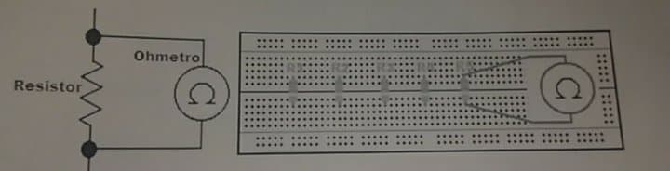

**Resistance**

**Ohmmeter**

Figure 1. Connection of Ohmmeter.

Table 1. Values of Resistances.

|  |  |  |  |
| --- | --- | --- | --- |
| Resistance | Value | Value from colors | Colors |
| R1 | 993.3 Ω | 1000 Ω | Brown – Black – Red |
| R2 | 678.9 Ω | 680 Ω | Blue – Gray - Brown |
| R3 | 330.4 Ω | 330 Ω | Orange – Orange - Brown |
| R4 | 554 Ω | 560 Ω | Green – Blue - |

## Use of Voltmeter

On figure 2 is showed how to measure voltage in one element. With volt source turned off, build the circuit showed on figure 3. As soon as you finished, turn on the volt source and fill the table 2.

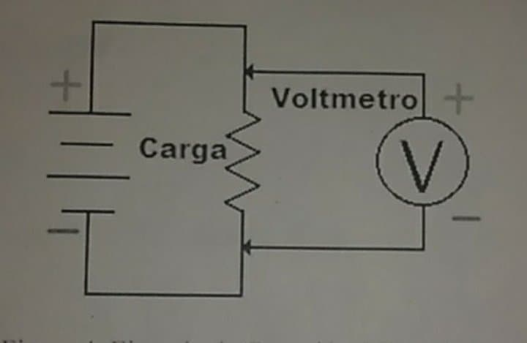

**Voltmeter**

**Charge**

Figure 2. How to measure voltage.

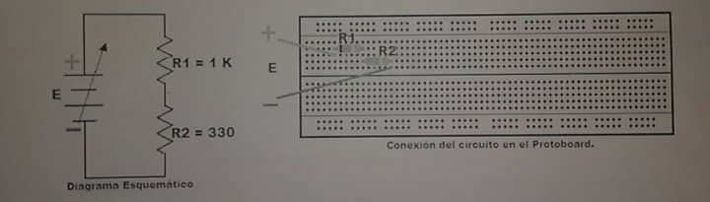

**Circuit**

**Schematic Diagram**

Figure 3. Circuit (Voltmeter).

Table 2. Values of Voltages.

|  |  |  |  |
| --- | --- | --- | --- |
| Voltage source | Digital multimeter | | |
| Voltage (R1 and R2) | Voltage (R1) | Voltage (R2) |
| E = 1V | 1.038 V | 0.781 V | 0.257 V |
| E = 2V | 1.974 V | 1.485 V | 0.489 V |
| E = 3V | 2.998 V | 2.253 V | 0.743 V |
| E = 4V | 4.036 V | 3.035 V | 1.001 V |
| E = 5V | 4.997 V | 3.758 V | 1.239 V |
| E = 6V | 6.017 V | 4.522 V | 1.493 V |
| E = 7V | 7.010 V | 5.27 V | 1.739 V |
| E = 8V | 8.020 V | 6.028 V | 1.990 V |
| E = 9V | 9.032 V | 6.788 V | 2.2424 V |
| E = 10V | 10.011 V | 7.525 V | 2.4859 V |
| E = 11V | 11.062 V | 8.313 V | 2.748 V |
| E = 12V | 12 V | 9.019 V | 2.9829 V |

## Use of Ammeter

On the figure 6 is showed how to connect an ammeter for electrical measures in one element.

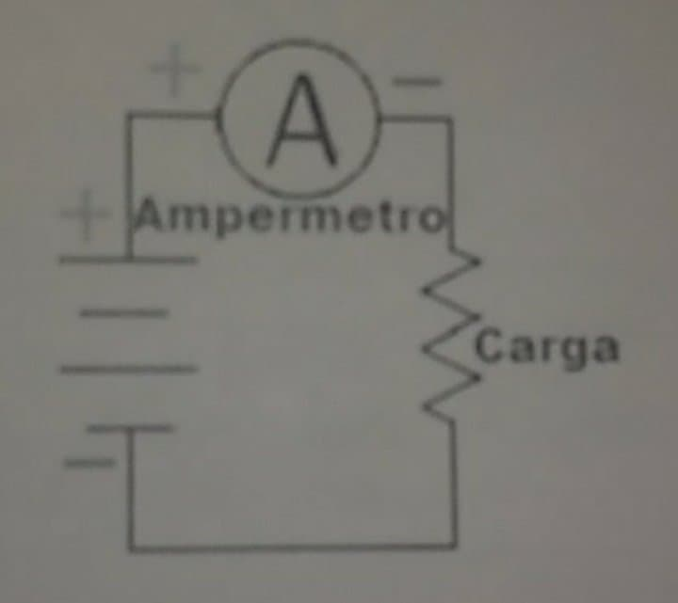

**Charge**

**Ammeter**

Figure 4. How to use an ammeter.

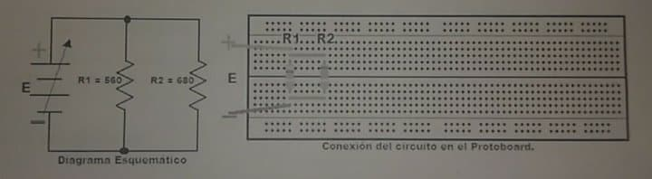

**Circuit**

**Schematic Diagram**

Figure 5. Circuit (Ammeter).

With the voltage source turned off, build the circuit from the figure 5. Once it is armed, turn on the voltage source and fill the table below.

Table 3. Values of Electrical Current.

|  |  |  |  |
| --- | --- | --- | --- |
| Voltage source | Digital multimeter | | |
| Electrical Current (R1 and R2) | Electrical Current (R1) | Electrical Current (R2) |
| E = 1V | 2.5093 mA | 1.5557 mA | 1.3 mA |
| E = 2V | 4.9630 mA | 3.020 mA | 2.5 mA |
| E = 3V | 9.826 mA | 4.617 mA | 3.8 mA |
| E = 4V | 13.014 mA | 7.186 mA | 5.83 mA |
| E = 5V | 16.266 mA | 9.071 mA | 7.44 mA |
| E = 6V | 19.534 mA | 10.808 mA | 8.83 mA |
| E = 7V | 22.891 mA | 12.628 mA | 10.36 mA |
| E = 8V | 26.232 mA | 14.467 mA | 11.80 mA |
| E = 9V | 29.59 mA | 16.309 mA | 13.36 mA |
| E = 10V | 32.72 mA | 18.150 mA | 14.86 mA |
| E = 11V | 36.37 mA | 19.959 mA | 16.34 mA |
| E = 12V | 39.69 mA | 21.9 mA | 17.83 mA |

## Questionary

### What is the characteristic of the Serial Circuit?

Elements feel same electric current and them voltage varies.

### What is the characteristic of the Serial Circuit?

Conversely, elements feel same voltage, but them experiment miscellaneous electric current,

### Why an ammeter can not be connected in parallel Form?

Because electric current varies, it is guessed to have no electric resistance.

### Why we should turn off the voltage source when we measure values of resistance in a circuit?

Because it varies.

# Conclusions

## Cabañas Baxcajay Jesús Francisco

It´s important to know perfectly the functioning of the materials we are going to work with in the circuits, since this will allow us to exploit their potential when creating circuits and in the same way to do so with the lowest risk of an accident occurring. It is necessary to know the theory of each component and then translate it into practice correctly. I hope to apply these knowledges in the future to innovate and create things that support society and the planet in general.

## Hernández Velázquez Ángel

Electronics has many uses today and is one of the most important fields of technology. Personally, I had never had any relationship with this, however, it is important to understand from its foundations to stop after to get a better result. As we saw in this practice, something as simple as Ohm's law and Kirchhoff's laws are the beginning of it, and everything is governed by physical principles.

## Martínez Coronel Brayan Yosafat

I had never done this before, I am afraid of electricity, but with this practice, I am more prepared for the next practices. I had said myself “You just need time to get it” and I feel better now. But talking about the knowledge, it is amazing to learn about new things. Knowing how electricity works, means we could make a lot of new things. The future is programming and mix it with electronic, so this is a great opportunity to start the road. If we learn this, we could make a better future, not just for Mexicans, for the humanity.

# Calculations

For this practice, there were no use of calculations.

# Simulations

This practice has no simulation.

